Chapter 10 Brandon veut un chien:

* Read chapter 10
* Do practice questions for chapter 10 and check answers.
* Take chapter 10 quiz and then transfer answers onto TEAMS.

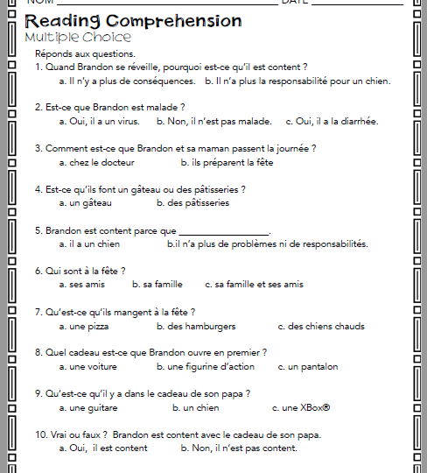

How did you do? Check your answers here ☺

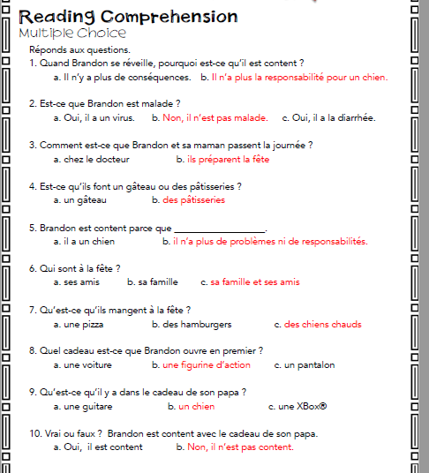

Chapter 10 QUIZ-Record your answers in TEAMS!

